BANGLA-GERMAN LATEX COMPANY LIMITED

**ABOUT US**

"I was most impressed with their facilities, which were amongst the best that I have seen."

David Smith

Chief  
Procurement Services Section  
**UNFPA**, Head Quarter, Denmark

**OUR MISSION**

**Better Condom,   Safer Sex**

Our mission is simple : to ensure quality condom production to contribute to the success of **Family Planning Program** (Bangladesh) and to provide active support in the field of **STI/HIV/AIDS** prevention program, to change safe sex as you know it. It started with our closest-to-wearing-nothing **FREEDOM** condoms. It continues today. Enjoy the ride.



**IN-HOUSE BRAND**

Our in-house brands are **FREEDOM** Safety, **FREEDOM** Pearl (dotted), **FREEDOM** Ribbed, **FREEDOM** Sperimicide and **FREEDOM** Color & Flavor.

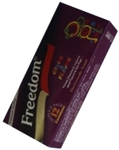

**COLOR & FLAVOR**

About the product here......

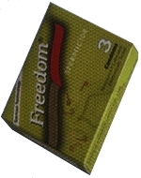

**SPERIMICIDE**

About the product here......

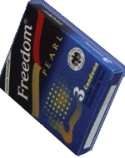

**PEARL (dotted)**

About the product here......

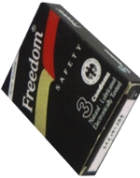

**SAFETY**

About the product here......

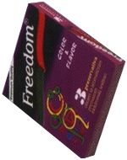

**COLOR & FLAVOR**

About the product here......

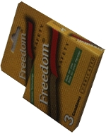

**SAFETY**

About the product here......

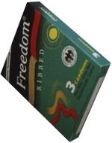

**RIBBED**

About the product here......

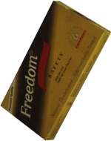

**SAFETY**

About the product here......

**BRANDS IN-HOUSE**

* [Color & Flabor-1](http://www.freedombglc.com/#prod-1)
* [Sperimicide](http://www.freedombglc.com/#prod-2)
* [Pearl (dotted)](http://www.freedombglc.com/#prod-3)
* [Safety-1](http://www.freedombglc.com/#prod-4)
* [Color & Favor-2](http://www.freedombglc.com/#prod-5)
* [Safety-2](http://www.freedombglc.com/#prod-6)
* [Ribbed](http://www.freedombglc.com/#prod-7)
* [Safety-3](http://www.freedombglc.com/#prod-8)

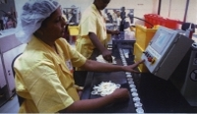

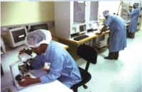

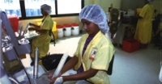

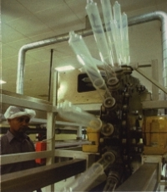

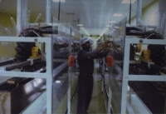

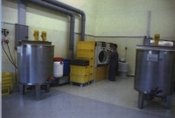

**TECHNICAL EXPERTISE**

Our partner **CPR Production-und Vertriebs GmbH,** Germany provides us all technical support to maintain the quality of condoms production. The production unit is run by foreign specialist with a working experience in world's top class condom factory abroad.

**PRODUCT & PRODUCTION**

Condom is a medical device class II (b) product and our production are certified according to EEC **Medical Device Directives (MDD)** Annexure **V 42/93/EC** and carries **"CE"** marking which means that these are else in the world. The chemical composition applied in our production conforms to the **US Code** of **Federal Regulation (USCFR) 21** and **XX1st** recommendations of **German Federal Health Department (DIN)**.

**Along with out German partner CPR Produktion - und Vertriebs GmbH our production capacity is 400 million pieces of condom per year.**

**QUALITY CONTROL**

We are committed to produce the finest quality of condoms. Our Quality Control laboratory is equipped with Burst Tester, Hole Tester, Tensile Tester, Aging Oven, Thickness Tester, Sealing Integrity Tester, facilities to measure length & width etc. and all the equipments are procured from **Germany** & **USA**. We have the only laboratory (in Bangladesh) which can perform **test** of **male latex condom** as per **WHO, ISO** & other internationally specified standards. Periodically our Germans partner also verifies the quality control procedure to ensure our quality & standard.

**MACHINERIES**

All the machineries are of German origin and are state of the art quality in the condom industry.

**RAW MATERIALS**

We produce raw materials from internationally reputed suppliers in Germany, Malaysia and Thailand with quality certificates.

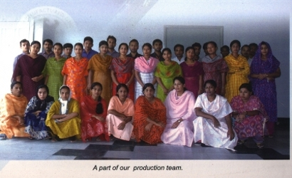

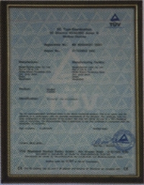

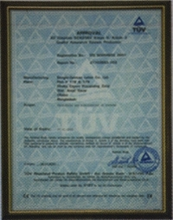

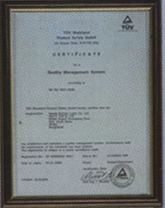

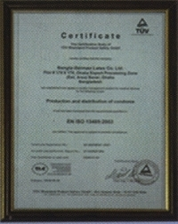

**CERTIFICATION**

We are routinely audited by **TUV, Rheinland, Germany** and awarded **CE 0197** mark and also certified with **ISO 9001:2000 & EN ISO 13485:2003.**

**THE COMPANY**

**Bangla-German Latex Company Limited, Bangladesh** is a joint venture with **CPR Production-und Vertriebs GmbH, Germany**. This was registered under the Companies Act, 1994 of Bangladesh as a public limited company on 25 April 1999. This is the only quality condom plant in the South Asian region other than India.

**OBJECTIVE**

The aim of the company is to bring together the expertise of one of the world's leading condoms manufacturers and produce quality latex condoms in Bangladesh. Our objective is to produce quality condom so as to contribute to the success of **family planning program** and to provide active support in the field of **STI/HIV/AIDS** **prevention program**, to ensure safe sex as you know it. It started with our closest-to-wearing-nothing **FREEDOM** condoms.

**SHAREHOLDERS**

Our Shareholders were from Germany, UK and Bangladesh.

**MANAGEMENT**

Our management team consists of local and international specialists having long experience in this industry.

**BUYERS**

Our prominent buyers included **IPPF (International Planned Parenthood Fund)-UK, CPR-Germany, UDL-Pakistan, ICDDR,B-Bangladesh and Save The Children-USA** and other clients in Myanmar, Bahrain, Honduras, and USA. We manufacture customized brand for different buyers & brands as desired by our valued customers.

**C  
O  
N  
T  
A  
C  
T  
  
U  
S**

**BANGLA-GERMAN LATEX CO. LTD.**

Plot # 178 & 179, Export Processing Zone (Extension Area)  
Ganakbari, Savar, Dhaka, Bangladesh.  
Phone: 88-02-7701857, 88-02-7701858, 88-02-7701859  
E-mail: bglc@rediffmail.com, www.freedombglc.com

**Powered By ©**